# **Section 10 Trees (91 points)**

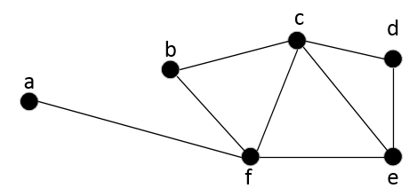Show your work, if possible, on the worksheet. If the answer is wrong and you've shown your work, you can receive partial credit. But if the answer is wrong and you haven't shown your work, there will be no credit for that question.

1. (18 points) For the given graph G:
   1. (2 pts) List the vertex set and the edge set of **G**.

Figure 1: Graph G

V = {a,b,c,d,e,f} E = {{a,f},{b,c},{b,f},{c,d},{c,e},{c,f},{d,e},{e,f}}

* 1. (2 pts) Which, if any, vertices are adjacent to vertex **e**?

C,d,f

* 1. (2 pts) List the neighbors of vertex **c**.

b,d,e,f

* 1. (2 pts) What is the degree of vertex **f**?

4

* 1. (2 pts) What is the total degree of **G**?

1+2+4+2+3+4 = 16

* 1. (2 pts) Is G a regular graph? Why or why not?

No because not all of the vertices have the same degree.

* 1. (3 pts) Is K3 a subgraph of G? If so, name the vertices in the subgraph.

Yes, c,e,f

* 1. (3 pts) Is K4 a subgraph of **G**? If so, name the vertices in the subgraph.

no

1. 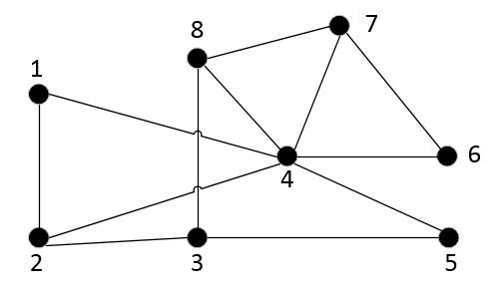 (18 points) For the given graph H:
   1. (2 pts) List the vertex set and the edge set of **H**.

Figure 1: Graph H

V = {1,2,3,4,5,6,7,8} E = {{1,2},{1,4},{2,3},{2,4},{3,5},{3,8},{4,5},{4,6},{4,7},{4,8},{6,7},{7,8}}

* 1. (2 pts) Which, if any, vertices are adjacent to vertex **6**?

4,7

* 1. (2 pts) List the neighbors of vertex **8**.

3,4,7

* 1. (2 pts) What is the degree of vertex **4**?

6

* 1. (2 pts) What is the total degree of **H**?

2+3+3+6+2+2+3+3= 24

* 1. (2 pts) Is **H** a regular graph? Why or why not?

No because not all of the vertices have the same degree.

* 1. (3 pts) Is K3 a subgraph of **H**? If so, name the vertices in the subgraph.

Yes 1,2,4

* 1. (3 pts) Is K4 a subgraph of **H**? If so, name the vertices in the subgraph.

no

1. 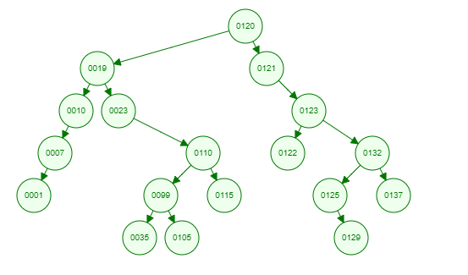 (30 points) For the given tree T:

(10 pts) Give the preorder traversal of the tree.

120, 19, 10, 7, 1, 23, 110, 99, 35, 105, 115, 121, 123, 122, 132, 125, 129, 137

* 1. (10 pts) Give the inorder traversal of the tree.

1, 7, 10, 19, 23, 35, 99, 105, 110, 115, 120, 121, 122, 123, 125, 129, 132, 137

* 1. (10 pts) Give the postorder traversal of the tree.

1, 7, 10, 35, 105, 99, 115, 110, 23, 19, 122, 129, 125, 137, 132, 123, 121, 120

1. (10 points) For tree T find the following:
   1. (2 pts) List all vertices of height 4.

1, 99, 115, 125, 137

* 1. (2 pts) List all leaf vertices.

1, 35, 105, 115, 122, 129, 137

* 1. (2 pts) List any siblings of vertex 0099.

115

* 1. (2 pts) What is the height of the subtree with root vertex 0110?

2

* 1. (2 pts) If any exist, show 1 subtree that is not a balanced tree (do not use vertex 0120).

123

1. (15 points) For the weighted graph W, show the minimal spanning tree of the following weighted graph using Kruskal's algorithm.

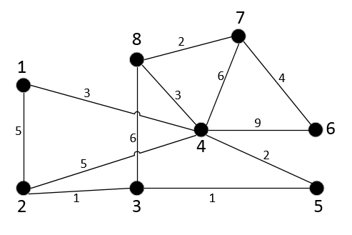

Figure 2: Weighted graph W

8

7

1

4

6

2

3

5

1+1+2+3+3+2+4 = 16